
The Honorable Chris Christie
Office of the Governor
PO Box 001
Trenton, NJ 08625

December 3, 2014

Dear Governor Christie,

We write urging that you dedicate $15 million to help middle income students pay for college with grants given directly from the states to students and to help make education more affordable for New Jersey residents.

We have attached a packet, which includes a white paper that explains our proposal that addresses the cost of higher education in New Jersey.

Lastly, we have also attached cards from some of your constituents, who support our proposal.

Sincerely,
College Students Concerned by College Costs (CSC ³)

The Honorable Chris Christie
Office of the Governor
PO Box 001
Trenton, NJ 08625

October 15, 2014
Dear Governor Christie,
We write urging that you dedicate $15 million to help middle income students pay for college with grants given directly from the states to students and to help make education more affordable for New Jersey residents. Grants will directly show that the state is supporting middle income families’ need to pay for college and will prevent middle income students, who have assumed the most student loan debt, from taking on more debt. Pennsylvania, one of New Jersey’s biggest competitor for college enrollment, is stealing students from New Jersey because the state supports higher education more and its institutions provide more aid to middle income students. As of right now, New Jersey is behind in higher education; it needs to use this proposed grant to promote a four year graduation rate and drive all higher education institutions to compete in price and value.
Higher education’s student loan system is highly controversial and highly problematic for individuals and institutions. The student loan system most definitely drives and aggravates the vicious cycle of institutional dependence on federal aid, tuition increases, and student loan debt. Consequently, high student loan debt causes many students to withdraw from the institution, wasting resources of the government and the institution. High student debt not only limits the purchasing power of students, but it also hinders the economy as students are the future consumers. While student loans are meant to provide education equity, loans actually limit access to college as there are no consumer protections and applying for loans is a daunting process. As a result of the current exorbitant student loan debt, it is easy to see why economists and politicians aim to fix the student loan system in order to fix the ills of higher education.
A major problem in the higher education system of New Jersey is that most legislation that are intended to aid middle class students do not actually do so. Instead, most bills and laws passed simply allow students easier access to privatized loan companies. This does not actually decrease the cost for students to attend higher education institutions, but rather makes it easier for students to acquire loans, which then translates into debt.
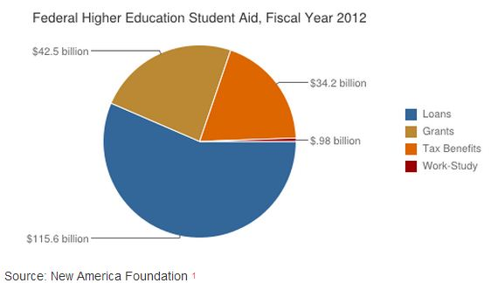
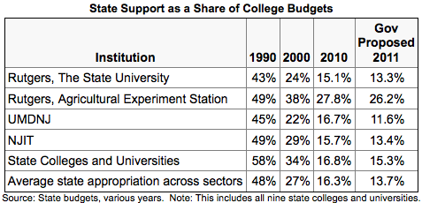
The table below shows Chris Christies 2011 proposed college budget. From the chart, there is an evident decline of funds given each year to each institution. Possible reasons are that listed institutions have become more independent, institutions do not require as much aid, or the state has provided more funds to private institutions.
The table below shows that out of around $193 billion of federal higher education student aid, only $42.5 billion was provided for grants to college students. Middle income students are less likely to get merit scholarships as they are less able to afford better academic preparation outside of secondary schools and are less likely to receive Pell Grants. $42.5 billion is not nearly enough to help middle income students attend and pay for college.

The table below shows the average state spending breakdown. New Jersey spends 13% of its state budget of $12 billion on higher education. The state spends 34% on disability aid, health benefits, pensions, economic development etc. The state gives too much aid to institutions, which increases the lack of academic success and the emphasis on reputation in higher education. The state should give money directly to the student to ensure better academic success and timely completion.
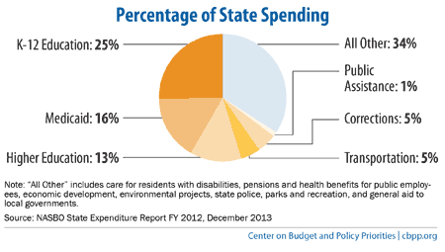
Also, while New Jersey has numerous state colleges and schools that are affordable and provide significant financial aid, students who attend colleges out of state are often left out. Often, most New Jersey grants and scholarships are waived when a student declares that they are attending college out of state. This leaves students going to school out of state without aid, forcing the full cost of college to be placed on the shoulders of the student and his family. Middle class families cannot afford to pay the entire cost of attending a higher education institution and therefore must take out loans. However, the problem with this is that the excessive interest rates along with the large amount of money borrowed places the student into an economic hole upon graduating college, which is very hard to climb out of. This hole prevents college graduates from moving out of their parents’ homes and establishing themselves independently in society.
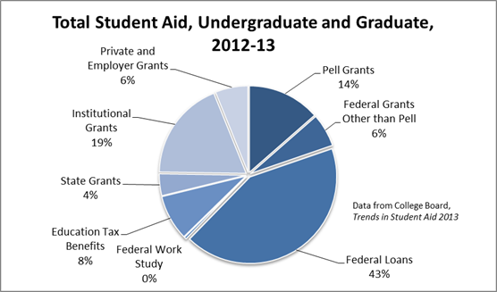
The chart shown above is a depiction of what resources students use to finance college in the United States. From the chart, we can see that most students use federal loans to pay for their education. Even though federal loans are from the government, these loans aren’t actually providing any aid to the students. The presence of loans only prolongs the payment period and the longer it takes for the student to be able to pay the loan back, the more interest there is on the loan which is keeping students in debt for longer after they graduate college.
Additionally, the students who have to take out loans to pay for college usually have to use other resources not shown on this graph, such as getting a job. Commonly, college students and graduates work in the restaurant business to help pay off their student loan debt. For example, a 2007 graduate from The College of New Jersey, was working as a teacher but also had to work as a waitress on several nights a week to pay off her student loans. At this point, she had been out of school for about 5 years and was still paying upwards of one thousand dollars each month towards her student loan debt. This is a problem because middle class families don’t get enough governmental aid to offset the magnitude of loan debt.
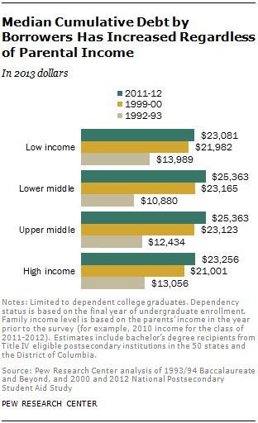
Furthermore, the individual states should assist students in financing college so they have less debt when they get out of college. More grants should be distributed to students to lower the total cost of their college education, not prolong the payment period like a loan does. The more grants given to students will lower the amount of loans they have to take out which will then lower the amount of debt they are in after graduation. Lastly, students are choosing to go to schools outside of New Jersey for financial reasons. Students are being offered more aid to go to schools outside of their home state. For example, many Widener students, who are from New Jersey, were offered more money to attend Widener University than they were to attend Rutgers University. As other states are seemingly providing more aid, New Jersey may be gaining a bad reputation regarding student debt relief and aid.
Current bills and federal aid assist students of low income families to pay for college. Likewise, students of high income families are able to pay out of pocket for college. So what happens with students of middle income families? Students who come from middle income families are forced to take out loans, which leave them in a tremendous amount of debt compared to students from low and high income families. Why are students from middle income families not receiving any aid to help them pay for college and their future? Should students from middle income families be attending college if they are going to have a ton of debt at the end?
According to the chart above, in the most recent year (2011-2012) the cumulative debt for lower middle income families has increased by 2.5 times that of (1999-2000). In addition, it shows that the cumulative debt for upper middle income families has nearly doubled since (1999-2000).
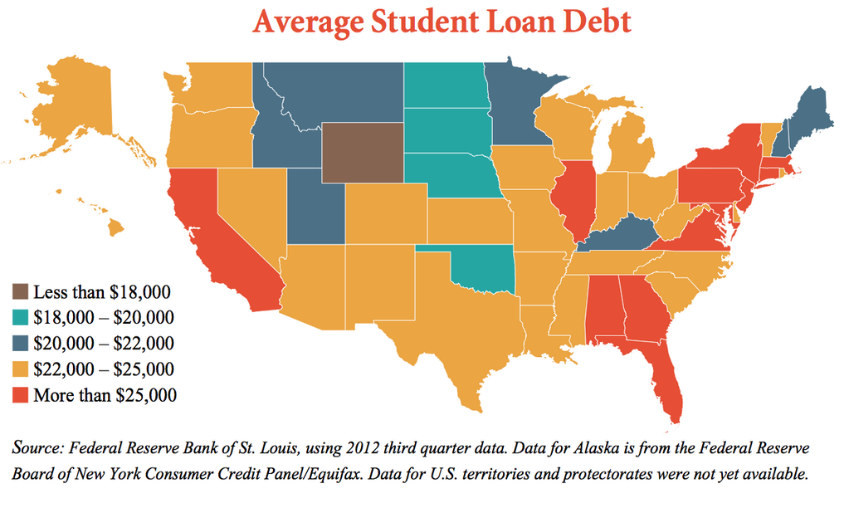
This chart takes a closer look at average student loan debt based on each state. Over half of the states have student loan debts from $22,000 and up. This is an outrageous number. Particularly of interest to us, the average student loan debt in New Jersey is over $25,000. New Jersey is one of the 12 states where the average student loan debt is this high. Note that given the scale in the chart, this is the highest average student loan debt amount.
After graduating, students are struggling to repay their loan debts because they are unable to find work that pays enough to allow them to relieve their debt burdens. Many graduates find themselves unemployed and unable to pay back their loans all together. This not only affects the students and their families, but it influences the return money on taxpayers’ investments to build a stronger, better-educated, and better-skilled workforce. In addition, this affects the economy because students have to put off significant life events like buying a house.
Should students from middle income families be attending college if they are going to have a ton of debt at the end? Students from middle income families attend college because they need jobs, they should not be punished for their parents’ average income. If they want to go to college why should money stop them? College is about education and furthering themselves as individuals. Students need to stop being looked at as a source of income for colleges and the government and rather be looked at as the next generation of job seekers and employers.
How can we fix student loan debt? One solution could be to eliminate Perkins Loans. The basis of a Perkins Loan is not based on the need of the students but rather by past allocations. It does not look at the current federal aid needed but rather at how it was needed in the past. In addition, if we stopped using the cost of attendance to determine aid eligibility and looked at the median cost to attend, this could give more-expensive colleges a motivation to cut costs and provide lower-cost colleges more resources to increase or progress. Lastly, the restructuring students loans needs to stop focusing on using loans as an investment in a factory and look at them as an investment in human capital for promising students.
Student loans and student debt are one of the greatest problems facing higher education. It would be detrimental to institutions that depend on tuition and students, who need loans to attend college in the first place, to eliminate the student loan system. Institutions’ finances are destabilized by student borrowing, which prompts institutions to create a financial barrier through increased tuition to minimize the loss of institutional resources for students who withdraw. The cost of college keeps increasing, but there have been derailed attempts by the state to make college more affordable, increase access to all, and encourage timely completion. New Jersey should give grants to students, not the institutions, because it would be impossible to sync the state’s legislative decisions with the policies of all institutions.
With support from the state, middle income students would have the ability to choose which college to attend based on price and the value of education. Grants to help middle income students will encourage these students to graduate in four-years and to have more academic success, as institutions will be forced to return their focus to the academic performance of students. The state is obligated to increase college access to middle income students because low income students receive federal aid and high income students can pay out of pocket. New Jersey holds an embarrassing amount of students in debt, but, with middle income student debt relief, the state can address the ills of its higher education system and redirect the state onto a path of future economic success by enrolling and keeping college students in the state.
Sincerely,
Rachel Breslin
Widener University ‘17
37 Beloit Avenue
Audubon, NJ 08106

Nicole Crossey
Widener University ‘16
43 Tennyson Drive
Plainsboro, NJ 08536

Deanna Laspata
Widener University ‘16
127 Cedar Road
Mullica Hill, NJ 08062

Matt Vesper
Widener University ‘17
524 Carol Avenue
Blackwood, NJ 08012

New Jersey State Budgets, 1995-2012.
New America Foundation, 2012.
NASBO State Expenditure Report FY 2012.
“Federal Tax Benefits for Higher Education,” Postsecondary National Policy Institute, 2012.
“Median Cumulative Debt by Borrowers Has Increased Regardless of Income,” Pew Research Center 2013.
Richard Fry, “The Changing Profile of Student Borrowers: Trends in Amounts Borrowed,” Pew Research Center, 2014.
Federal Bank of St. Louis, 2012. http://www.politifact.com/texas/statements/2014/jun/09/pete-gallego/pete-gallego-equates-average-student-loan-debt-pri/
“Where is the Average Student Loan Burden the Largest,” 2014. http://saldutticollect.com/wpblog/archives/2571
“For Profit Higher Education: The Failure to Safeguard the Federal Investment and Ensure Student Success,” United States Senate, 2012.
Andrew Gillen, “To Fix Student Lending, Rethink the Concept,” The Chronicle of Higher Education, 2012.

